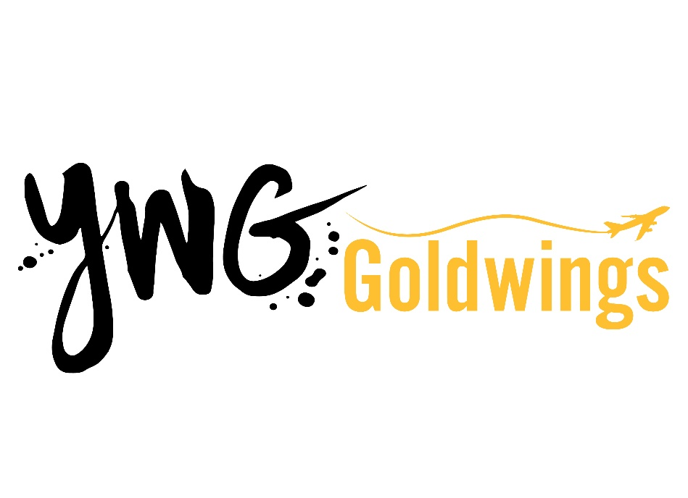

Acronyms
ACAM: Access Control and Monitoring System
AED: Automated External Defibrillator
ATB: Air Terminal Building
AOC: Airport Operations Centre
ASP: ASP Airport Security Services (Info Booth/Baggage Drop)
ATAP: Anti-Tailgating Access Portal
BDA: Bag Drop Attendant
BIDS: Baggage Information Display System
BIWIS: Baggage Image & Weight Information System
BOC: Baggage Operations Coordinator
BHS: Baggage Handling System
BTRS: Baggage Tracking & Reconciliation System
CATSA: Canadian Air Transport Security Authority
CBSA: Canada Border Services Agency
CCTV: Closed Circuit Television
CSA: Customer Service Agent
CUCE: Common-Use Computer Equipment
CUPPS: Common-Use Passenger Processing System
CUSS Kiosk: Common-Use Self-Serve Kiosk
DMDS: Directional Motion Detection System
EOC: Emergency Operations Centre
FIDS: Flight Information Display System
GTL: Ground Transportation Liaison
LAGS: Liquids, Aerosols, Gels
MAO: Manager, Airport Operations
NPS: Non-Passenger Screening
PASS: Paladin Aviation Security Services
PBB: Passenger Boarding Bridge
PBS: Pre-Board Screening
PIL: Primary Inspection Line
PSL: Primary Security Line
RAIC: Restricted Access Identification Card
RCMP: Royal Canadian Mounted Police
SRG/Logixx: Security Resource Group/Logixx (a subsidiary of SRG)
TC: Transport Canada
TSC: Transportation Security Clearance
TSS: Transportation Security Services
USCBP: U.S. Customs and Border Protection
VPD: Visitor Pass Decal
WAA: Winnipeg Airports Authority
WHILL: Autonomous Wheelchair (self-driving)
WRIA: Winnipeg Richardson International Airport
YWG: Winnipeg’s Airport Code

